# **Project Documentation**

**Project Overview:**

WhatsNext Vision Motors, the industry trailblazer in the automotive sector, aims to revolutionize the mobility market with cutting-edge technology and solutions focused on customer-centric needs. The company has undertaken a grand Salesforce initiative with the fundamental goal of amplifying the customer experience and its operational process simplification. At the core of this project lies enhancing the customers' ordering process. The system will automatically propose the closest dealer location to customers according to their address. The idea is to considerably make the ordering experience more convenient and efficient, more customer-centric, and less time- and effort-consuming on the customer side.

The project also solves a typical problem in the car industry: stock availability. The system incorporates a mechanism to prevent orders for out-of-stock vehicles. This is a preventive measure that ensures customers can only place orders for vehicles that are in stock, thereby avoiding possible confusion and disappointment due to a lack of stock. This functionality not only increases customer satisfaction but also enhances the company's order fulfillment process accuracy.

In addition, the project involves a timed process for updating the bulk order records status. This process has been automated in order to update the status of the order as per stock availability. If the vehicle is not available when the order is placed, the system will change the status of the order to 'Pending.' Conversely, if the vehicle is available, the system will change the status to 'Confirmed.'

The deployment of this Salesforce project at WhatsNext Vision Motors should bring about numerous advantages. It should make the ordering system more effective, lowering the risk of errors and enhancing the overall service to customers. Through simplification of the ordering process and confirmation of stock availability, the company can improve customer satisfaction and loyalty.

In addition, the project is anticipated to help improve operational effectiveness by minimizing the administrative workload on employees. With the automation of some processes, employees are able to dedicate more time and effort to strategic activities that involve human judgment and skills. Not only does this enhance the overall output of the company, but it also facilitates a quicker reaction to marketplace and customer needs.

**Objectives:**

* Simplify the vehicle ordering process with Salesforce CRM.
* Auto-assigned orders to the closest dealer based on location.
* Avoid orders of out-of-stock vehicles with Apex triggers.
* Automate order status changes and test drive reminder emails.
* Implement stock updates and order processing with batch jobs and scheduled Apex.
* Improve customer satisfaction, order accuracy, and business efficiency.

**Phase 1: Requirement Analysis & Planning**

1. Understanding Business Needs

Customer Requirements: Quick, precise car ordering; real-time notifications.

Problems Addressed: Avoid out-of-stock orders, automate dealer allocation, give unambiguous order status, minimize manual processes.

2. Project Scope and Goals

Scope: Deploy Salesforce CRM to manage cars, dealers, orders, test drives, and services.

Goals:

* Improve customer satisfaction.
* Automate order allocation and stock verification.
* Increase operating efficiency.
* Guarantee accurate, real-time information.

3. Data Model & Security

Custom Objects: Vehicle__c, Dealer__c, Order__c, TestDrive__c, ServiceRequest__c

Key Relationships: Vehicles ↔ Dealers (many-to-many), Orders → Customer/Vehicle/Dealer

Security Model: Role hierarchy, permission sets, field-level security, region-based sharing.

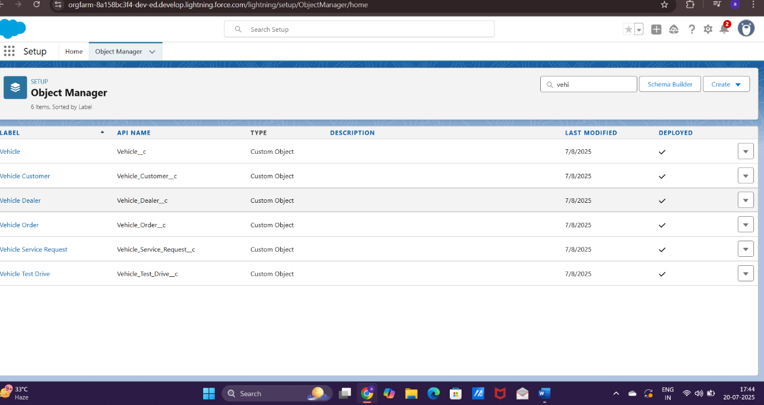

**Phase 2: Salesforce Development - Backend & Configurations**

1. Environment Setup & DevOps Workflow

Sandboxes: Developer, Developer Pro, and Full Copy sandboxes used for isolated development and testing.

Version Control: Git repository used for code versioning and collaboration.

DevOps Tools: Gearset / Copado (or other chosen CI/CD tools) for:

* Metadata deployment between environments
* Automated testing and validation
* Release pipeline management

2. Salesforce Customization (Declarative Development)

| **Object Name** | **Key Fields** |
| --- | --- |
| Vehicle__c | Model, Variant, Price, Stock_Available__c (Number) |
| Dealer__c | Name, Location__c (Geolocation), Region |
| Order__c | Customer, Vehicle, Dealer, Status__c (Picklist) |
| TestDrive__c | Customer, Vehicle, Scheduled_Date__c |
| ServiceRequest__c | Type, Status, Assigned_Technician__c |

3. Apex Development

* OrderAssignmentHelper.cls: Assigns the nearest dealer based on customer location
* StockValidator.cls: Checks stock availability and blocks out-of-stock orders

| **Trigger Name** | **Description** |
| --- | --- |
| OrderTrigger | Before insert/update: validate stock and assign dealer |
| VehicleTrigger | After update: notify when stock falls below threshold |
| TestDriveTrigger | After insert: schedule email reminder |

4. Asynchronous Apex

Batch Apex Job (OrderStatusUpdaterBatch.cls)

Purpose: Periodically updates order statuses based on stock availability

Schedule: Daily via ScheduleBatch.cls

Logic:

* If vehicle stock = 0 → update order to 'Pending'
* If vehicle stock > 0 → update order to 'Confirmed'

Future/Queueable Apex (if required later):- For sending bulk email notifications or recalculating pricing asynchronously.

**Phase 3: UI/UX Development & Customization**

1. Create a Lightning App

Steps to Create:

Navigate: Setup → Search "App Manager" → Click New Lightning App

Fill App Details - App Name: WhatsNext Vision Motors

Description: CRM for vehicle sales, service & dealer management

Keep Defaults for: App Options → Utility Items → Navigation Rules

Add Navigation Items - Objects: Vehicle, Dealer, Customer, Order, Test Drive, Service Request

Reports and Dashboards

Assign Profiles - Add: System Administrator (can add more based on roles)

Save & Finish

2. Lightning Tabs & Navigation

Tabs created for quick access to major business modules:

* Vehicles
* Dealers
* Orders
* Customers
* Test Drives
* Service Requests
* Reports & Dashboards

1. Custom Object UI Fields (Key Fields)

| **Object** | **Key Fields** |
| --- | --- |
| **Vehicle__c** | Vehicle_Name, Vehicle_Model (Picklist), Stock_Quantity, Price, Status |
| **Vehicle_Dealer__c** | Dealer_Name, Dealer_Location, Dealer_Code (Auto), Phone, Email |
| **Vehicle_Order__c** | Customer, Vehicle, Order_Date, Status (Pending/Confirmed/Delivered/Canceled) |
| **Vehicle_Customer__c** | Customer_Name, Email, Phone, Address, Preferred_Vehicle_Type (Picklist) |
| **Vehicle_Test_Drive__c** | Customer, Vehicle, Test_Drive_Date, Status (Scheduled/Completed/Canceled) |
| **Vehicle_Service_Request__c** | Customer, Vehicle, Service_Date, Issue_Description, Status |

4. Lightning App Builder Customizations

Built “WhatNext Vision Motors CRM” App with:

* Home page dashboard: Order stats, stock levels, service KPIs
* Record pages tailored per object with highlights, related lists, and quick actions
* Compact layouts for mobile optimization

5. User Experience Enhancements

Quick Actions: Create Order, Schedule Test Drive, Log Service Request

Dynamic Forms: Show/hide fields based on vehicle or status

Record Pages: Customized layouts for each object

**Phase 4: Data Migration, Testing & Security**

1. Data Loading Process

Data Import Wizard: For small volumes or simple data like customers and dealers. User-friendly UI inside Salesforce Setup.

Data Loader: For bulk and complex data loads (vehicles, orders, test drives). Handles large CSV files with parent-child relationships.

Load Sequence:

* Vehicle_Dealer__c
* Vehicle__c
* Vehicle_Customer__c
* Vehicle_Order__c
* Vehicle_Test_Drive__c
* Vehicle_Service_Request__c

1. Data Integrity Controls

Field History Tracking: Enabled on key fields such as Status__c on Vehicle, Order, Test Drive objects to track changes.

Duplicate Rules: Prevent duplicate customers using email and phone number matching.

Matching Rules: Define criteria (e.g., exact email + phone match) to identify duplicates before record creation.

1. Security Model

Profiles: Define permissions (System Admin, Sales Rep, Service Agent, Dealer Manager).

Roles & Role Hierarchy: CEO > Regional Manager > Dealer Manager > Sales/Service Rep, enabling record visibility.

Permission Sets: Add fine-grained access, e.g., approval rights, special task creation permissions.

Sharing Rules: Automate data sharing based on regions or departments for dealers and service requests.

1. Test Classes & Test Cases

Develop Apex test classes to cover all triggers, batch jobs, and Apex classes with at least 75-90% coverage.

Prepare test cases documenting:

* Booking creation (valid and invalid)
* Approval process flow
* Automatic task creation on test drives
* Flow executions
* Trigger validations (e.g., stock check, dealer assignment)
* Include input and output screenshots for each test case to demonstrate functionality and correctness

1. Record-Triggered Flows

Flow 1: Assign Nearest Dealer on Order Creation

Trigger: When a Vehicle_Order__c record is created (Before Save).

Process:

* Retrieve customer location from related Vehicle_Customer__c record.
* Query all Dealer__c records and compare location proximity (basic region or city match in Flow; for accurate geo-calculation, consider Apex).
* Assign the closest Dealer__c to Vehicle_Order__c.Dealer__c field automatically.

Flow 2: Send Test Drive Reminder Email

Trigger: When a Vehicle_Test_Drive__c record is created with Status = Scheduled (After Save).

Process:

* Fetch the customer’s email from related Vehicle_Customer__c record.
* Send an email using the Send Email action with test drive details like date, vehicle name, and contact info.

**\*(Source Code Posted In GitHub)\***

**Phase 5: Deployment, Documentation & Maintenance**

1. Deployment Strategy

Change Sets:

* Used for migrating metadata (objects, fields, flows, Apex classes, etc.) from Sandbox to Production.
* Prepare Outbound Change Sets in Sandbox, include components, and upload to Production.
* Validate deployment in Production before final deployment.
* Best for point-to-point Salesforce orgs with moderate complexity.

Alternative Methods (if needed):

* Salesforce CLI (SFDX): For more complex or automated deployments, CI/CD pipelines.
* ANT Migration Tool: Useful for scripted and bulk metadata deployment.

Deployment Best Practices:

* Freeze changes during deployment window.
* Perform testing in sandbox and UAT before production deployment.
* Communicate deployment schedule with stakeholders.

1. System Maintenance & Monitoring

Ongoing Maintenance:

* Regular review of workflows, flows, and Apex for optimization and performance.
* Monitor data quality and duplicate management rules.
* Keep documentation and training updated for new features or changes.
* Provide user support and handle change requests.

Monitoring Tools:

* Use Salesforce Setup Audit Trail to track configuration changes.
* Debug Logs and Error Notifications for Apex and flow errors.
* Reports and dashboards to monitor key metrics like order processing times and stock levels.

1. Troubleshooting Approach

Step 1: Identify and reproduce the issue in a sandbox or dev environment.

Step 2: Check system logs, debug logs, and error emails to isolate root cause.

Step 3: Review related configuration — workflows, triggers, flows, validation rules.

Step 4: Collaborate with stakeholders and developers to validate fixes.

Step 5: Test fixes thoroughly in sandbox, then deploy with proper communication.

Step 6: Document the issue and resolution steps in a knowledge base for future reference.

**Conclusion**

The successful rollout of the Salesforce CRM at WhatsNext Vision Motors represents a key milestone towards the company's digital transformation and customer-centric innovation. Through this multi-stage project, the organization has:

* Streamlined its customer ordering process by facilitating real-time stock verification and intelligent dealer assignment.
* Improved operational efficiency through automated workflows, batch jobs, and custom flows for order management, test drive scheduling, and service handling.
* Developed a solid and expandable data model that supports inventory of vehicles, customer interactions, and service lifecycle management.
* Established rigorous data integrity, security, and access control through profiles, roles, and sharing rules.
* Implemented test-driven development and tiered deployment strategy to support easy go-live and high levels of standards.

With processes thoroughly documented, automated surveillance, and a proactive support system in place, WhatsNext Vision Motors is now poised to provide quicker, more intelligent, and more tailored customer experiences—without compromising on agility and preparedness for future innovation in the mobility space.